**MERGE OPERATION**

**MERGE:**

MERGE INTO COP1 C USING EMP E

ON(C.AGE = E.AGE)

WHEN MATCHED THEN UPDATE

SET

C.LAST_NAME = E.LAST_NAME

WHEN NOT MATCHED THEN INSERT

VALUES(E.LAST_NAME,E.AGE);

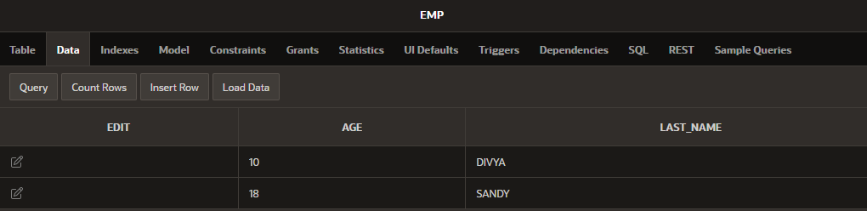

**SEQUENCE:**

CREATE SEQUENCE sequence_1

INCREMENT BY 1

START WITH 1

MAXVALUE 50000

NOCACHE

NOCYCLE;

**SELECT sequence_name, min_value, max_value, increment_by,**

**last_number**

**FROM user_sequences;**

CREATE TABLE students

(

ID number(10),

NAME char(20)

);

**INSERT into students VALUES**

**(sequence_1.nextval,'Shubham');**

**INSERT into students VALUES**

**(sequence_1.nextval,'Aman');**



**MULTIVALUE MERGING:**

INSERT ALL INTO EMP

VALUES(AGE,LAST_NAME)

INTO COP1

VALUES(AGE,LAST_NAME)

SELECT AGE,LAST_NAME

FROM EMP;

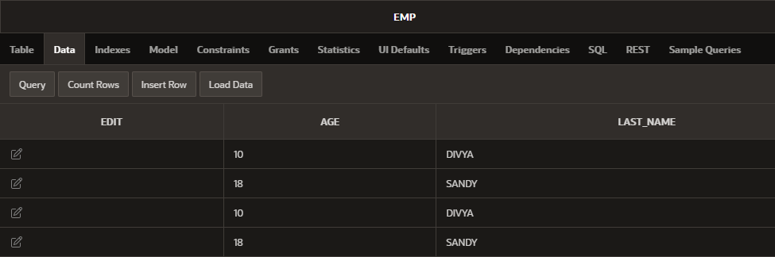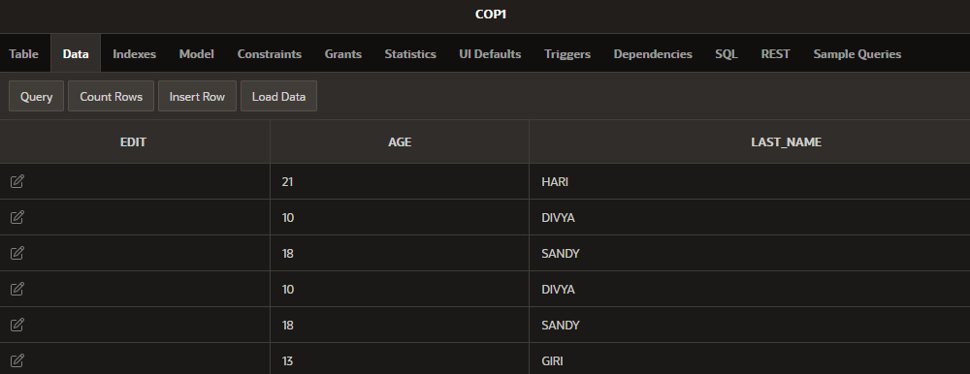

* **“SELECT AND CREATE” COMMENT GIVE IN SAME QUERY;**

CREATE TABLE COP3

AS SELECT *FROM COP1;

**USED TABLE:**

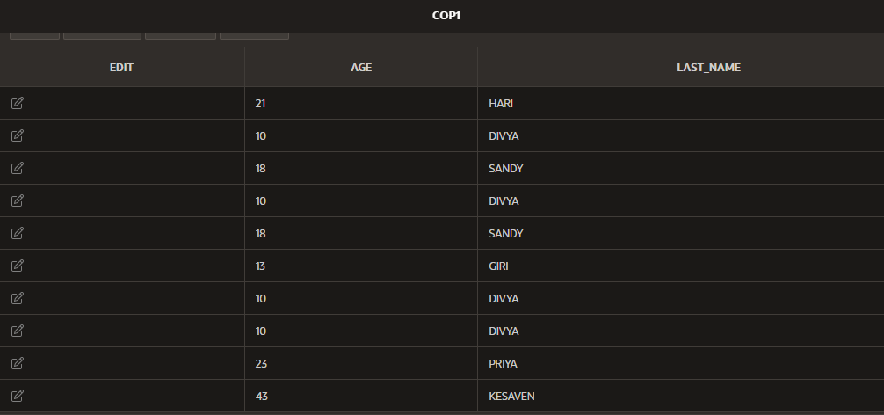

**OUTPUT TABLE:**

